Gödöllői Egyetemi Atlétikai Club
Vívószakosztály

2103 Gödöllő, Páter K. u. 1.

The Fencing Section of GEAC
has the pleasure of inviting you in the season of 2013/2014 to the Gödöllő International Veteran Competition. The competition is organised for fencers above 40 in men’s sabre and women’s sabre.

Location: | GEAC Fencing Hall  Gödöllő, Szent István Egyetem (SZIE) 2103, Páter Károly u. 1.  It is located in the main buiding of the SZIE University, please see the attached map
Date: | 10 May 2014, Saturday  11:00 – male and female sabre
Participation: | All fencers born before 01 January 1975.
Categories:  Registration: | 40 + all fencers born between 1974 – 1965  50 + all fencers born between1964 – 1955  60 + all fencers born between1954 – 1945  70 + all fencers born between 1944 – 1935  Pre registration deadline: 8 May 2014  Please send the registration to Laszlo Takacsy to the following e-mail address: takacsyl@gmail.com. On site registration is also possible.
Check-in (on site registration): | No later than 30 minutes prior to the start of the tournament at the DT.  Medical certificate or medical liability statement on spot is obligatory.
Registration fee: | 10 EUR / person / event
Format of the tournament: | According to the number of entries, the DT will define the format.
Others:  Emergency call: | Organisers provide the referees.  Finalists (1-3) receive medal prizes  In case of emergency, please call Laszlo Takacsy: +36 30 687 9181.
We kindly ask all competitors to wear clean and valid fencing equipment.
Fencing suit 350N or 800N (FIE) with under plastron, mask 350N or 1600N (FIE),
all types of blades are allowed.

The organisers take the responsibility only for the objects given to the organisers.

Accomodation: | Please ask the organisers for local accomodation info.

Budapest, 22 April 2014

Csaba Gémesi
Section leader

Directions to the GEAC Fencing Hall:

On google Maps you can find it under this link:

https://www.google.com/maps/search/p%C3%A1ter+k%C3%A1roly+u.+1/@47.5958995,19.3602508,16z/data=!4m5!2m4!3m3!1zcMOhdGVyIGvDoXJvbHkgdS4gMQ!2zR8O2ZMO2bGzFkSwgTWFneWFyb3JzesOhZw!3s0x4741c9171f68656b:0x400c4290c1e1a00

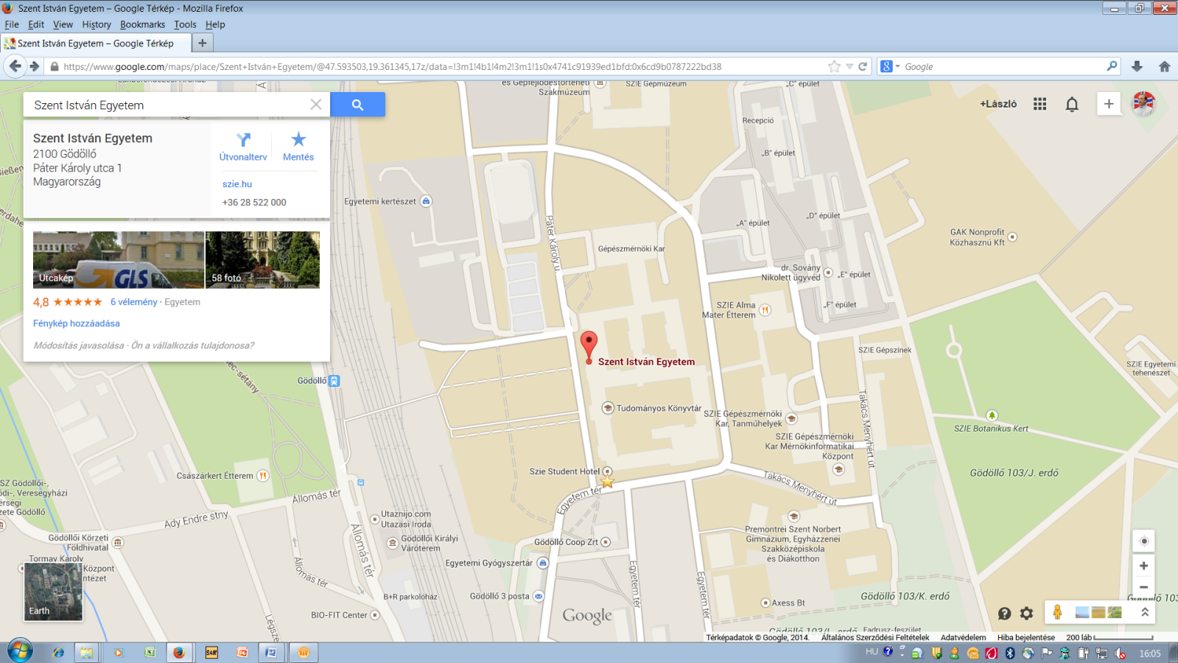
You have to take the main entrance, which is in the old building, opposite the bronz statue of Prince Kalman. Then you have to follow the signs, ask the porter or give me a call (Laszlo: +36 30 687 9181).

